Lab: Database Basics MySQL Queries
Problems for exercises and homework for the "Programming Fundamentals" course @ SoftUni.
Submit your solutions (source code) of all below described problems in the Judge.

Create New Database
First start HeidiSQL. Then write a query that will create the "softuni" database.
Queries are written in the "Query" tab:
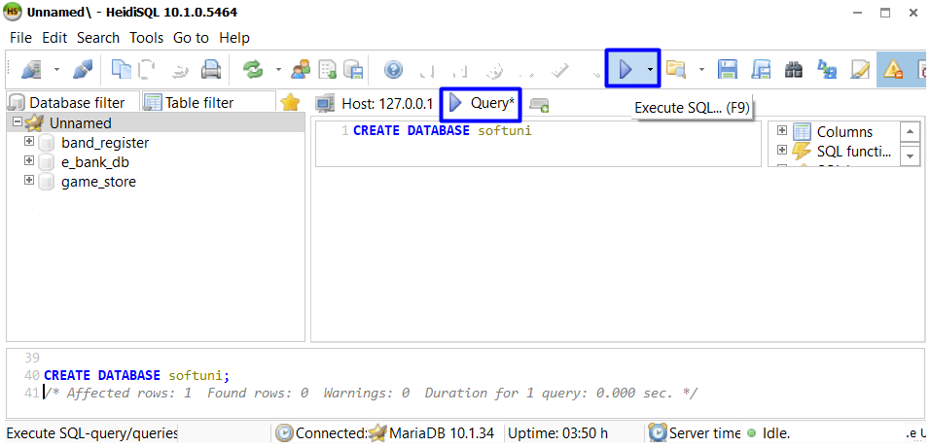
When we create database, we specify the database we want to use. This is done by using the "USE" clause:
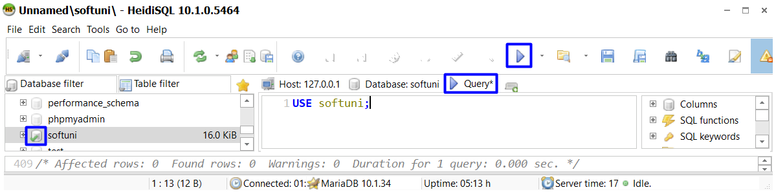

Create Table
Submit your solutions in JUDGE without the "USE {database name}" row:
Using HeidiSQL in database "softuni" create table "students". You should specify five columns:
- Name: id, Datatype: INT, Autoincrement, Primary Key
- Name: first_name, Datatype: VARCHAR, Max Length: 50, Allow NULL: true
- Name: last_name, Datatype: VARCHAR, Max Length: 50, Allow NULL: true
- Name: age, Datatype: INT, Allow NULL: true
- Name grade, Datatype: DOUBLE, Allow NULL: true

Insert Data
Insert 6 recordings in "students" table.

Example
Id | first_name | last_name | age | grade
1 | Guy | Gilbert | 15 | 4.5
2 | Kevin | Brown | 17 | 5.4
3 | Roberto | Tamburello | 19 | 6
4 | Linda | Smith | 18 | 5
5 | John | Stones | 16 | 4.25
6 | Nicole | Nelson | 17 | 5.50

Find All Records
Write a query to find all records.

Find Last Name, Age and Grade
Write a query to find last name, age and grade of each student.
last_name | age | grade
Gilbert | 15 | 4.5
Brown | 17 | 5.4
Tamburello | 19 | 6
Smith | 18 | 5
Stones | 16 | 4.25
Nelson | 17 | 5.50

Find First 5 Records
Write a query to find first 5 records.
Id | first_name | last_name | age | grade
1 | Guy | Gilbert | 15 | 4.5
2 | Kevin | Brown | 17 | 5.4
3 | Roberto | Tamburello | 19 | 6
4 | Linda | Smith | 18 | 5
5 | John | Stones | 16 | 4.25

Find First 5 Last Name and Grade
Write a query to find top 5 records. Select only last name and grade.

last_name | grade
Gilbert | 4.5
Brown | 5.4
Tamburello | 6
Smith | 5
Stones | 4.25

Truncate Table
Remove all records in "students" table.

Drop Table
Drop table "students".

Drop Database
Drop database "softuni".

